Product Line Profitability & Margin Performance Analysis for Nassau Candy Distributor

Name :- Aarya Nirankar Nikam

Abstract :-
In today's competitive business environment, analyzing profitability is essential for effective decision-making. This project performs a profitability analysis of the Nassau Candy Distributor dataset using Microsoft Excel and Exploratory Data Analysis (EDA) techniques. The analysis includes Product-Level Profitability, Division-Level Performance, Pareto (80/20) Analysis, and Cost Structure Diagnostics using Pivot Tables, charts, and dashboards.
Key performance metrics such as Sales, Gross Profit, Gross Margin, Revenue Share, and Profit Contribution were calculated to evaluate business performance. The study identified the most profitable products, underperforming products, division-wise financial efficiency, and areas with pricing and cost optimization opportunities.
The findings show that a small number of products contribute the majority of the company's revenue and profit, while several products generate minimal returns. Based on these insights, recommendations such as optimizing pricing, reducing costs, promoting high-margin products, and reviewing low-performing products for discontinuation were proposed. This project demonstrates how EDA and Excel can support data-driven business decisions and improve overall profitability.

Introduction:-
Background
In today's competitive business environment, organizations must focus on profitability rather than sales alone. Products with high sales may not always generate high profits because production costs and pricing strategies directly affect financial performance.
This study uses Exploratory Data Analysis (EDA) in Microsoft Excel to analyze the Nassau Candy Distributor dataset and identify profitable products, division performance, and cost optimization opportunities.

Problem Statement
Although the company generates significant sales, it lacks a clear understanding of which products and divisions contribute most to profitability. High sales do not always result in high profits because manufacturing costs and profit margins vary across products. Some products may generate strong revenue while reducing overall profitability due to higher costs or inefficient pricing. Therefore, there is a need to identify profitable products, evaluate division-wise performance, optimize pricing strategies, and improve cost management to enhance overall business performance.

Objectives
The main objectives of this study are:
- To analyze the profitability of products using sales and gross profit data.
- To calculate and compare gross margins across different products.
- To evaluate the financial performance of different divisions.
- To perform Pareto (80/20) analysis to identify products contributing the most to revenue and profit.
- To analyze the cost structure and identify pricing inefficiencies.
- To develop an interactive dashboard in Microsoft Excel for business reporting.
- To provide data-driven recommendations for improving profitability and operational efficiency.

Dataset Description
The dataset used in this project is the Nassau Candy Distributor sales dataset, which contains information related to product sales, production costs, gross profit, product divisions, and geographic regions. The dataset was analyzed using Microsoft Excel to evaluate the company's financial performance and identify opportunities for improving profitability.
The dataset includes product-level and regional sales information, allowing detailed analysis of revenue, cost, and profit across different business segments. Key attributes in the dataset include Product Name, Division, Sales, Cost, Gross Profit, Region, State, Country, and Order Quantity. These variables were used to calculate important business metrics such as Gross Margin (%), Revenue Share (%), Profit Contribution (%), and Profit per Unit.
The dataset provides sufficient information to perform Product-Level Profitability Analysis, Division-Level Performance Analysis, Pareto (80/20) Analysis, and Cost Structure Diagnostics, helping identify the products and divisions that contribute most to the company's overall profitability.

Metric | Value
Total Records | 10,194
Total Products | 15
Total Divisions | 3
Total Regions | 4
Total Sales | 1,41,783.63
Total Gross Profit | 93,442.80

Data Preprocessing
Before performing the analysis, the dataset was cleaned and prepared to ensure accurate and reliable results. The following preprocessing steps were carried out:
- Verified the dataset for missing or blank values.
- Checked for duplicate records and ensured data consistency.
- Validated data types for numerical and categorical columns.
- Calculated Gross Profit using the formula:
Gross Profit = Sales − Cost
- Calculated Gross Margin (%) using:
Gross Margin = (Gross Profit ÷ Sales) × 100
- Calculated Profit per Unit, Revenue Share (%), and Profit Contribution (%) for profitability analysis.
- Created Pivot Tables to summarize product-wise, division-wise, and region-wise performance.
- Sorted products and divisions based on sales and gross profit for comparative analysis.
- Prepared charts and visualizations, including bar charts, pie charts, and scatter plots, to support Exploratory Data Analysis (EDA).
After preprocessing, the dataset was ready for detailed analysis, enabling meaningful insights into product profitability, cost structure, division performance, and overall business efficiency.

Exploratory Data Analysis (EDA)
Exploratory Data Analysis (EDA) was conducted to understand the sales, profitability, and cost patterns within the Nassau Candy Distributor dataset. Microsoft Excel was used to clean, summarize, and visualize the data through Pivot Tables, charts, and calculated metrics.
The analysis included:
- Product Profitability Analysis: Examined product-wise sales, gross profit, and gross margin (%) to identify high-performing and low-performing products.
- Division-Level Analysis: Compared sales, gross profit, and average gross margins across different divisions to assess financial efficiency.
- Pareto Analysis (80/20): Determined the percentage of products contributing to 80% of the company's revenue and profit, highlighting product concentration.
- Regional Analysis: Compared revenue and profit across regions to identify geographic concentration and over-dependency risks.
- Cost Structure Diagnostics: Analyzed the relationship between sales and production costs using a scatter plot to identify cost-heavy, margin-poor products and pricing inefficiencies.
The EDA process provided a comprehensive understanding of the company's sales, profitability, cost structure, and regional performance, forming the foundation for business recommendations.
sno. | Product Name | Sales | Gross Profit | Margin %
1 | Everlasting Gobstopper | 130 | 104 | 80.0
2 | Hair Toffee | 76.5 | 59.5 | 77.8
3 | Wonka Bar - Nutty Crunch Surprise | 23574.95 | 16819.95 | 71.3
4 | Wonka Bar -Scrumdiddlyumptious | 27874.8 | 19357.5 | 64.9
5 | Wonka Bar - Fudge Mallows | 24890.4 | 16593.6 | 58.5
6 | Wonka Bar - Triple Dazzle Caramel | 28485 | 18610.2 | 52.1
7 | Wonka Bar - Milk Chocolate | 26867.75 | 17443.37 | 45.6
8 | Laffy Taffy | 53.73 | 33.48 | 39.2
9 | Fizzy Lifting Drinks | 78.75 | 47.25 | 32.8
10 | Wonka Gum | 597.5 | 310.7 | 26.3
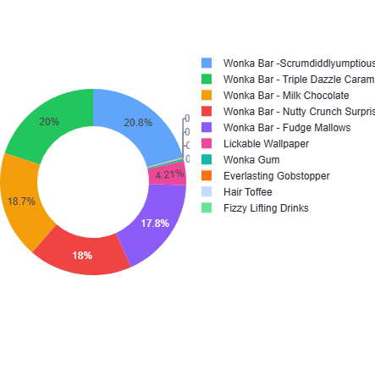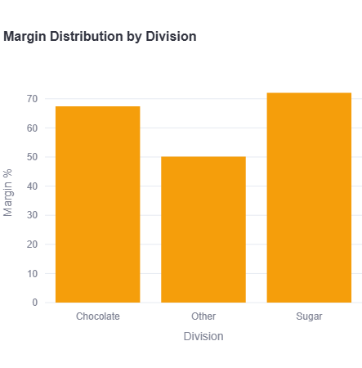

Results and Key Insights
The analysis revealed several important findings regarding the company's financial performance:
- Wonka Bar products generated the highest sales and profit.
- Lickable Wallpaper recorded the lowest gross margin and requires pricing review.
- Chocolate Division achieved the highest sales, profit, and margin performance.
- Pacific and Atlantic regions contributed the majority of revenue and profit).
- Pareto analysis showed that a small group of products generated most of the company's revenue and profit.
Overall, the findings demonstrate that profitability depends not only on sales volume but also on effective cost management and pricing strategies. The insights obtained from this analysis can help management improve profitability, optimize product portfolios, and support data-driven business decisions.
Division | Total Sales | Gross Profit | Gross Margin (%)
Chocolate | 1,31,692.90 | 88,824.62 | 67.45
Other | 9,663.25 | 4,333.45 | 44.84
Sugar | 427.48 | 284.73 | 66.61

- Table indicates that the Chocolate Division generated the highest sales and gross profit, making it the most financially efficient division. In contrast, the Other Division recorded lower profitability, suggesting opportunities for cost and pricing improvements.
Region | Total Sales | Gross Profit
Pacific | 46,301.53 | 30,485.94
Atlantic | 41,197.24 | 26,973.70
Interior | 32,037.60 | 21,282.49
Gulf | 22,247.26 | 14,700.67

- Table shows that the Pacific and Atlantic regions contributed the highest sales and gross profit, demonstrating strong market performance. The Interior and Gulf regions generated comparatively lower revenue and profit, indicating potential areas for business expansion..

Business Recommendations
Based on the findings of the profitability analysis, the following recommendations are proposed to improve the company's financial performance:
- Focus on high-performing products: Increase marketing efforts and inventory for high-profit products such as the Wonka Bar product line, as they contribute significantly to overall revenue and profit.
- Review pricing strategies: Reassess the pricing of products with lower gross margins, particularly Lickable Wallpaper, to improve profitability while remaining competitive.
- Reduce production costs: Optimize manufacturing processes and renegotiate supplier contracts for products with relatively high costs to improve gross margins.
- Optimize the product portfolio: Review low-performing products such as Fun Dip, Nerds, Laffy Taffy, SweeTARTS, Hair Toffee, and Fizzy Lifting Drinks for possible discontinuation or targeted promotional strategies.
- Reduce geographic dependency: Expand sales and marketing efforts in underperforming regions to reduce reliance on the Pacific and Atlantic regions.
- Implement regular profitability monitoring: Use dashboards and periodic profitability analysis to track product and division performance and support timely business decisions.

Conclusion
This study successfully analyzed the profitability of the Nassau Candy Distributor using Microsoft Excel and Exploratory Data Analysis (EDA) techniques. Various analyses, including Product-Level Profitability, Division-Level Performance, Pareto Analysis, and Cost Structure Diagnostics, provided valuable insights into the company's financial performance.
The results showed that a small number of products generated the majority of the company's revenue and profit, while several products contributed very little to overall profitability. The analysis also highlighted differences in financial performance across divisions and regions, along with opportunities to improve pricing strategies and reduce production costs.
Overall, the project demonstrates that combining EDA with Excel-based visualization and dashboard techniques enables organizations to transform raw business data into actionable insights. The recommendations provided can help improve profitability, optimize resource allocation, and support more effective strategic decision-making.

